**User Personas**

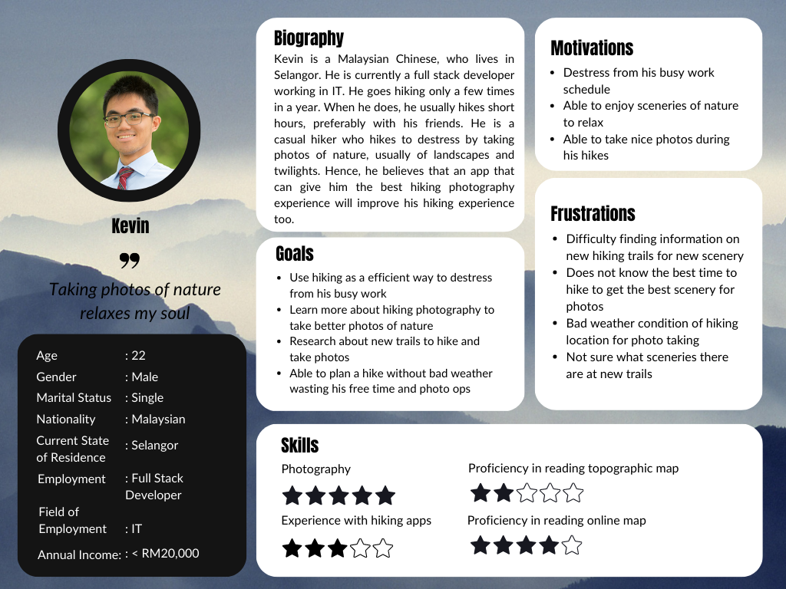

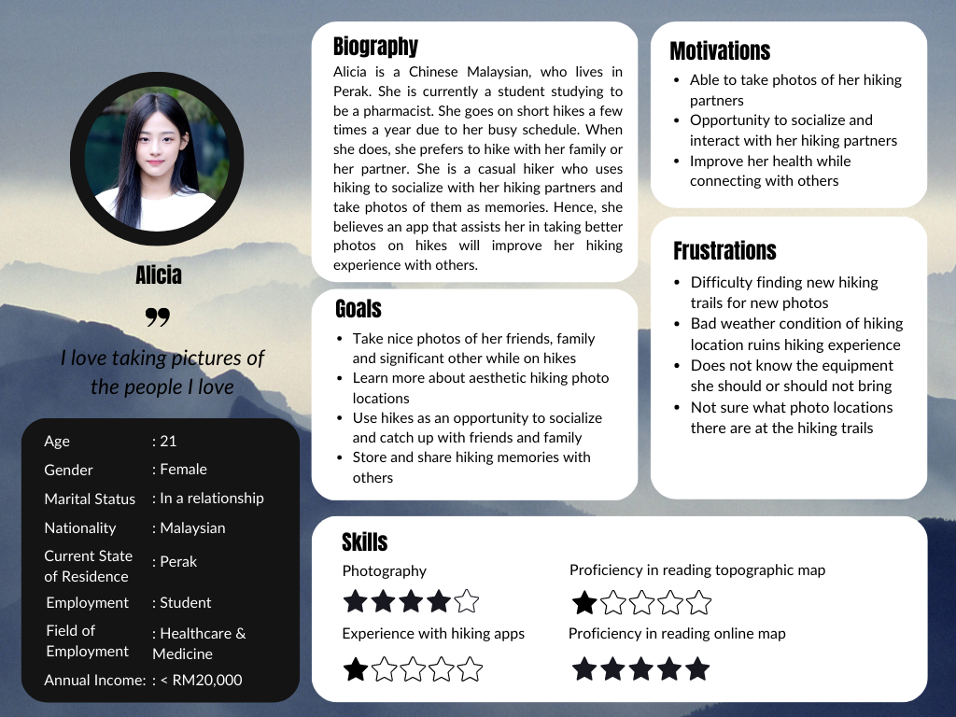

**User Stories**

| Priority | User Stories | Justification |
| --- | --- | --- |
| Must Have | * As Kevin, I want to be able to easily find new hiking trails, so that I can have new trails to hike and destress. * As Kevin, I want to know about the weather condition of the hiking trail, so that it won't ruin my photo ops. * As Kevin, I want to be able to know the best time for hiking photography, so that I can capture the best scenery photos * As Alicia, I want to know the best photo locations at each trail, so that I can take nice photos of my hiking partners. * As Kevin, I want to know about new scenery on hiking trails, so that I can take photos of new scenery. | Our hiking app’s main focus is to accurately provide hiking trail information to our users so that they have the best hiking photography experience. Information listed in these user stories, such as hiking trail locations, weather conditions and best duration to hike, are essential information for our users in order for them to successfully plan a hike for pictures. Hence, we must implement features to display this information to our users.  Our hiking app also has a side objective of potentially providing suitable hiking photography information for our users to have the best hiking photography experience on their hiking journey. Hence, providing information on the best photo locations or scenic routes during a hike through already existing pictures can help improve their experience. |
| Should Have | * As Alicia, I want to know the suitable photo equipment to bring during a hike, so that I won't have trouble carrying it around. | Knowing what equipment to bring can also be significant when planning a hike on steep or wet terrain. Better equipment can also be recommended depending on the possible photo ops. However, since this information is quite subjective, it is more difficult to provide accurate information on it. |
| Could Have | * As Alicia, I want to plan hiking groups with my friends, so I can catch up with them within my busy schedule. | Our hiking app also plans to have community features that allows users to share photos and interact with each other. So, having a system that allows users to hike or plan hikes together could be a possible implementation for our community features on top of the photo sharing features. |
| Won’t Have | * As Alicia, I want to know my health information like burnt calories as I hike, so I can keep track of my health. | As of now, we do not have any intention of adding fitness-related features to our hiking app. Although potentially useful, it is not a significant feature for us to implement at this time. |

**Additional Requirements**

**A feature that displays best photo-taking locations on a hike**

This feature would be for people who are interested in taking pictures during a hike. Based on our analysis, the majority of people were greatly interested in a feature that could recommend the best photo taking spots on hiking trails. Kevin and Alicia would both benefit from a feature like this as well since unique types of photos, such as Kevin’s scenery and Alicia’s social photos can be taken at different scenic locations. The feature on the app could be embedded onto the map, showing images of the scenic locations on the hike or it could be displayed for users to look through in list form. Users would be able to have a reference of the photo-taking location, which can help them greatly in planning their hiking photography journey. Furthermore, we can also categorise the locations into different views such as landscape, waterfall, flora and many more.

**A feature that displays tip and tutorials for hiking photography**

This feature would be for people who are interested in learning about hiking photography and want to improve their hiking photography skills. Based on our analysis, the majority of people are interested in having a feature that could provide hiking photography tips and tutorials. Kevin and Alicia also benefit from this feature as it will help them improve the quality of the photos taken. The feature on the app could provide recommendations on photo angles, perspectives and lighting in different locations and weather conditions. For Kevin, the feature could also give users the best time of the day to capture photos, such as sunrise and sunset, so that users can plan their hikes accordingly. For Alicia, the feature could show example photos for her to reference poses and shots. Additional tips and tutorials can be added after further development.

**Individual Analysis/Reflection**

My 2 user personas, Kevin and Alicia were created based on the analysis and overall result from our questionnaire responses. Each persona was assigned some basic demographic information to help visualise their situation, along with a biography, goals, motivation and challenges regarding hiking activities. The rating stars are given based on an average of the scores for the listed skills from our questionnaire responses. Additionally, a quote is also given to summarise their goal in hiking.

The basic demographic information of the 2 personas is based on the majority results on the demographic related questions. Hence, both personas are created to be Malaysian Chinese in the 18 to 25 years old age range in order to capture the perspective given by our majority user group. My responsibility in this assignment was to focus more on the people who are interested or participate in hiking photography, either casual or experienced. Therefore, I also created the personas based on the user group that responded with favourable scores regarding their photography skills, which is a score of 3, 4 or 5 for all photography-related design decisions. The usability-focused information is mostly based on the photography-related usability questions, with small references to the hiking related questions.

For Kevin, I created him to be a developer working in IT and living in Selangor. Kevin was created to be a person that was interested in hiking photography, while I created Alicia to be a student studying to be a pharmacist and living in Perak. Both have an interest in hiking photography and usually go on short hikes. However, their motivations differ where Kevin hikes to take scenic photos which helps him to destress, while Alicia hikes to catch up with her relationships by socialising during the hike and taking good pictures of the people she loves, like her family, friends and significant others. Additionally, Kevin prefers to take pictures of landscapes and twilights, while Alicia likes to take social pictures in general, like pictures of herself, others and her hiking experience. For Kevin and Alicia, all their demographic information and motivations are created based on the majority information on their respective genders from the questionnaire.

With these 2 personas, I was able to have deeper insights regarding the motivations and frustrations of our users associated with their goals. Therefore, we can effectively explain how and why they would engage with our app using user stories crafted based on the created personas. Now, the need to refer to the raw data decreases immensely, which helps me to focus on my targeted user group more easily. Then, photography-related app features can be suggested in my requirements which are decided and justified based on my user story priorities.